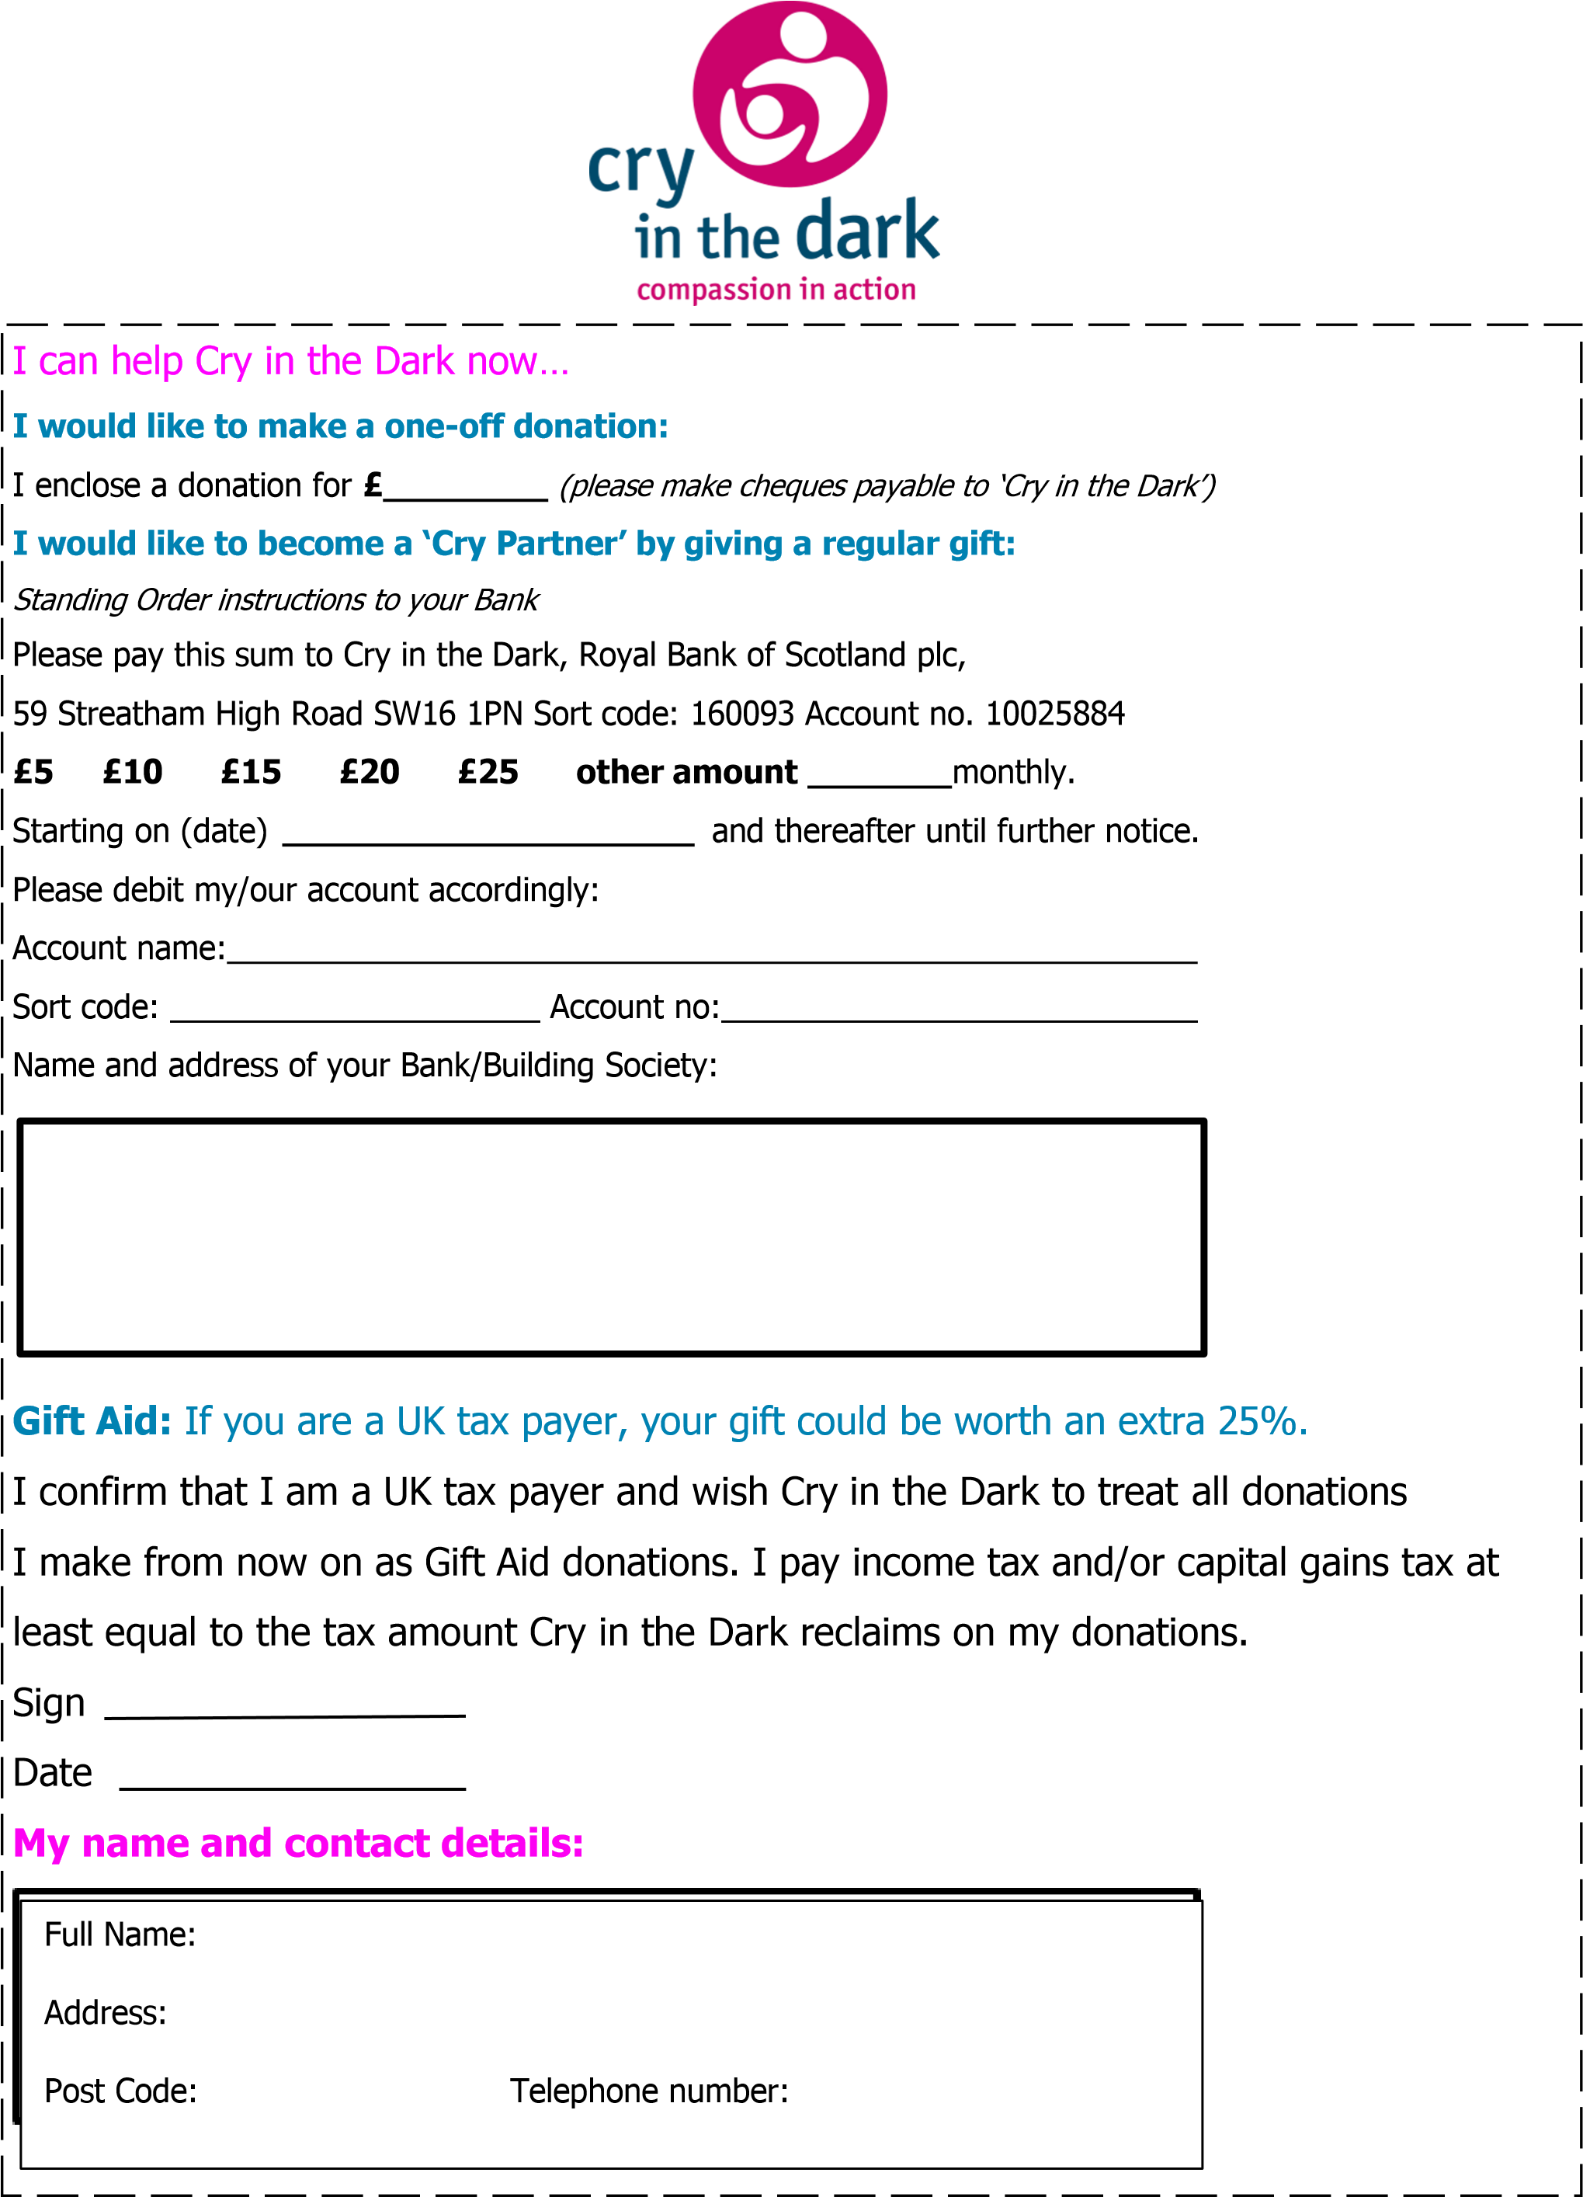
26 Winterbourne Gardens, Elmstead Green, Elmstead Market Colchester, Essex, CO7 7FG
E-mail: bethjohnson@cryinthedark.org Web: www.cryinthedark.org

